This document goes over the procedure for saving your school related files to Microsoft’s Cloud commonly known as “OneDrive”

**Saving Directly to your OneDrive from any Microsoft Office Programs**

**Step 1.)** In the Top Left corner click “File”

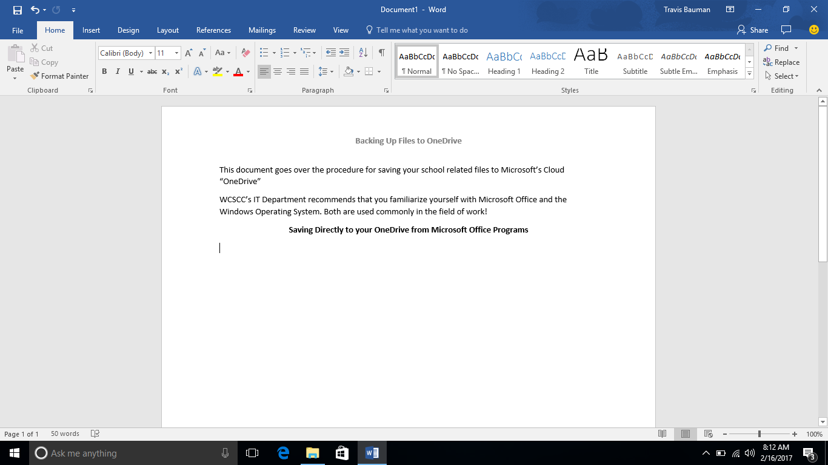

**Step 2.)** Click “Save As”

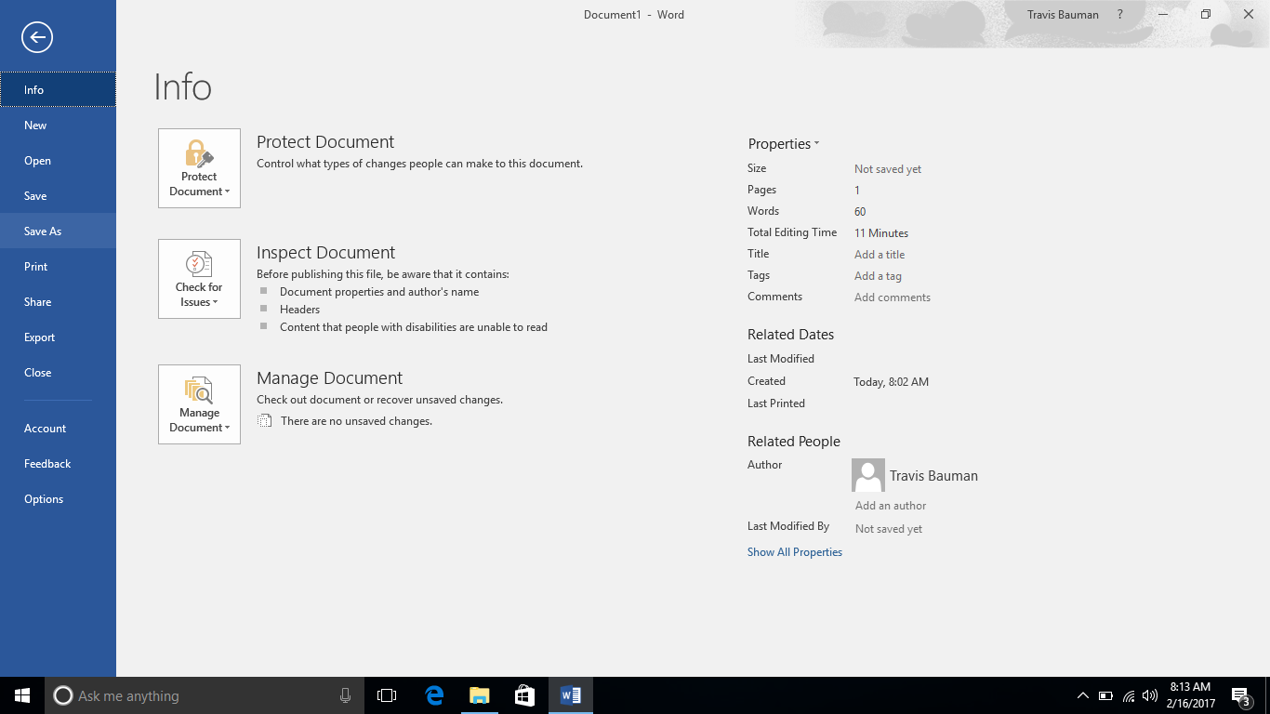

**Step 3.)** At this screen, you want to make sure that the “OneDrive – Wayne County Schools Career Center” save location is selected. Also, at this screen, you want to give your document an appropriate filename. When finished, click “Save”

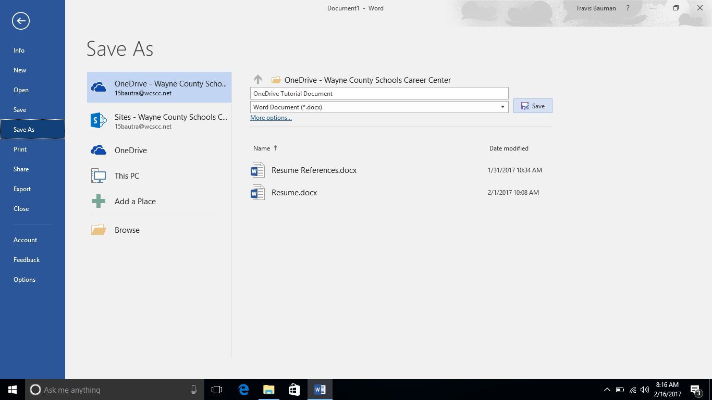

3

2

1

Now, Your document is saved locally in the “OneDrive - Wayne County Schools Career Center” folder on your Desktop and the file will automatically sync with the OneDrive cloud!

**Saving Any Other School Related File to OneDrive!**

**Step 1.)** To Backup any other important "School Related" file, Right Click the file, and choose to “Copy” or “Cut” the file. “Copy” Duplicates the file. “Cut” Moves the file.

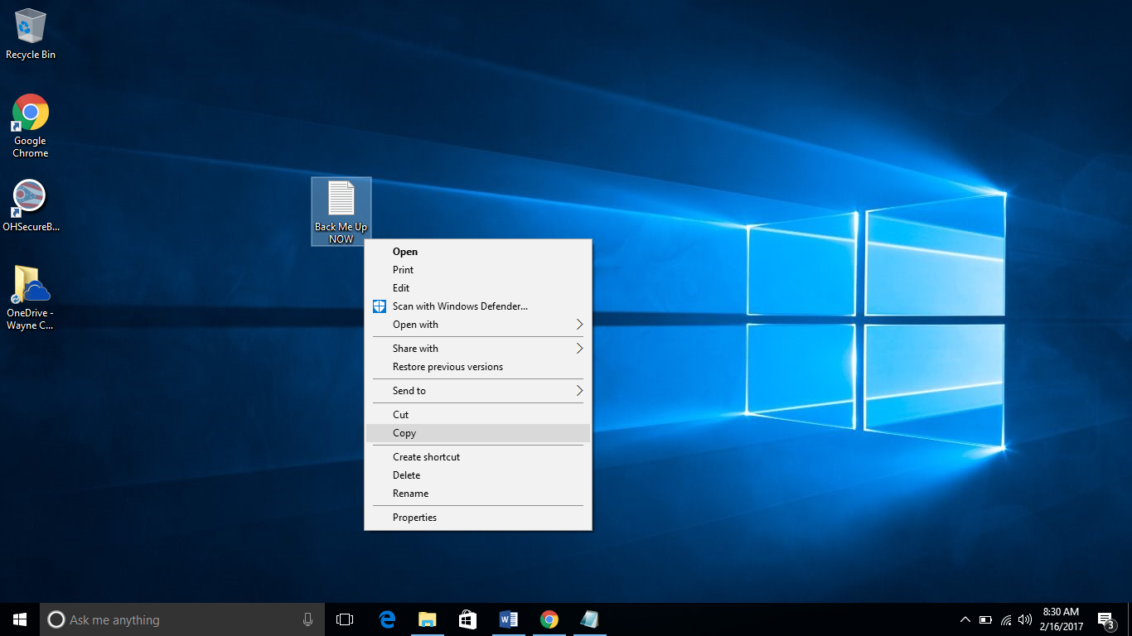

**Step 2.)** Open the “OneDrive – Wayne County Schools Career Center” folder on your desktop.

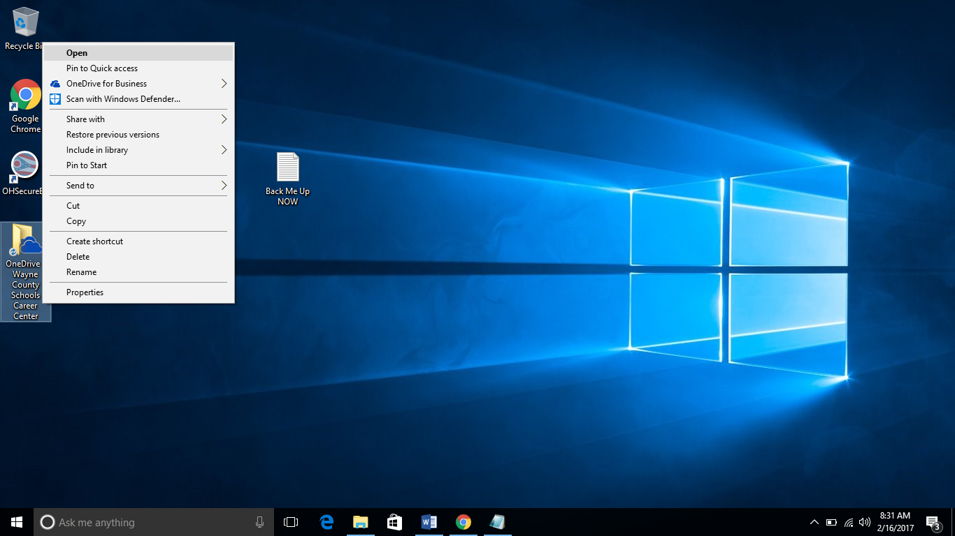

**Step 3.)** Right Click anywhere in the white space and click “Paste”

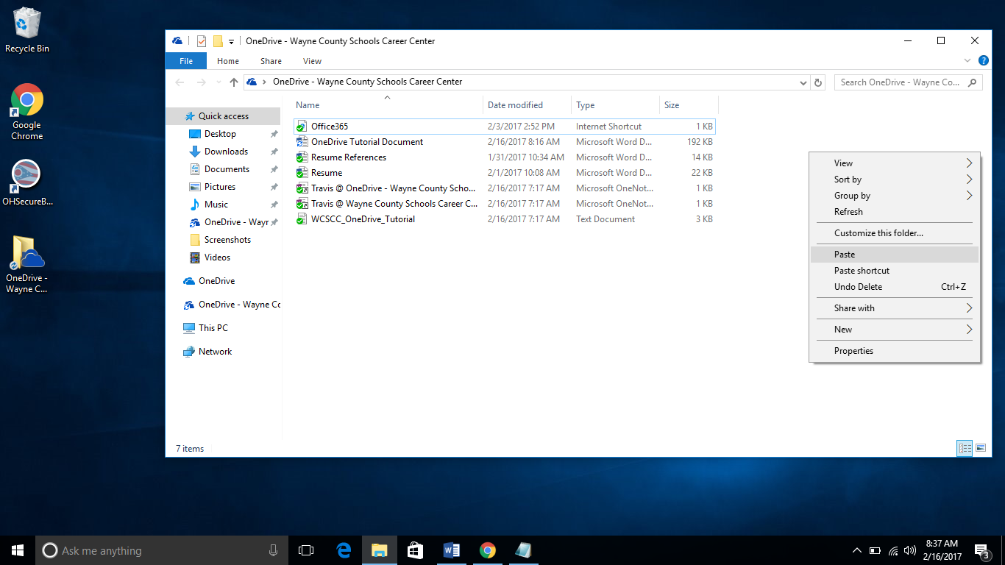

You Should Now see your file in the “OneDrive – Wayne County Schools Career Center” folder! The file will be automatically synced to OneDrive’s cloud in a few seconds if you have an internet connection.

**Accessing Files Saved in OneDrive Using A Web Browser From Anywhere at Anytime**

**Step 1.)** Open your favorite Web Browser. In the URL bar, navigate to “www.office.com”

Example of a Web Browser -> “Google Chrome”



**Step 2.)** Click “Sign In” in the Top Right corner.

**Step 3.)** Type your school email and password in the appropriate box. Then click “Sign In”

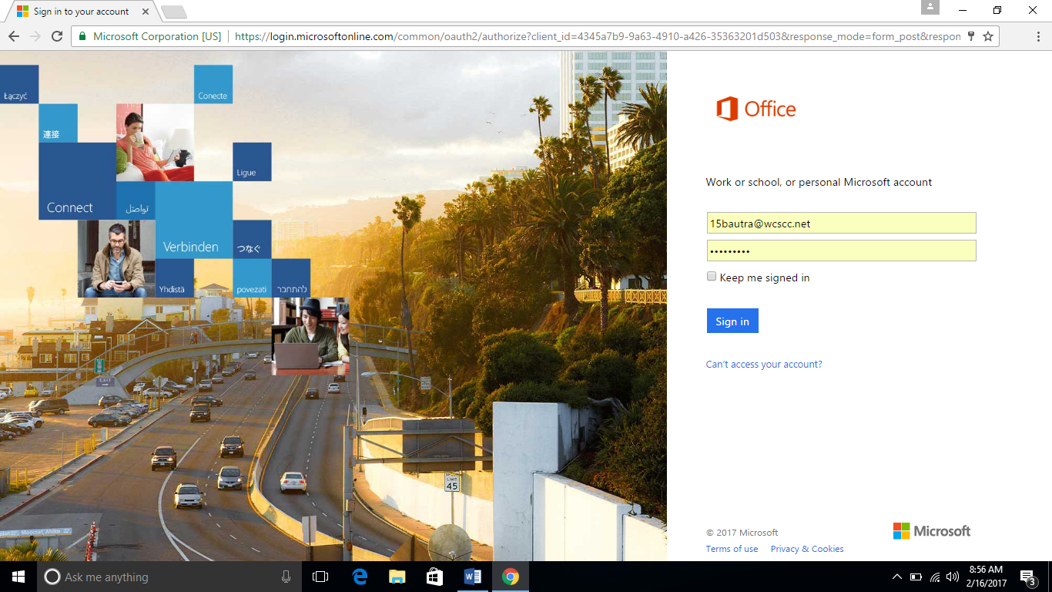

**Step 4.)** If prompted, choose “Work or school account”

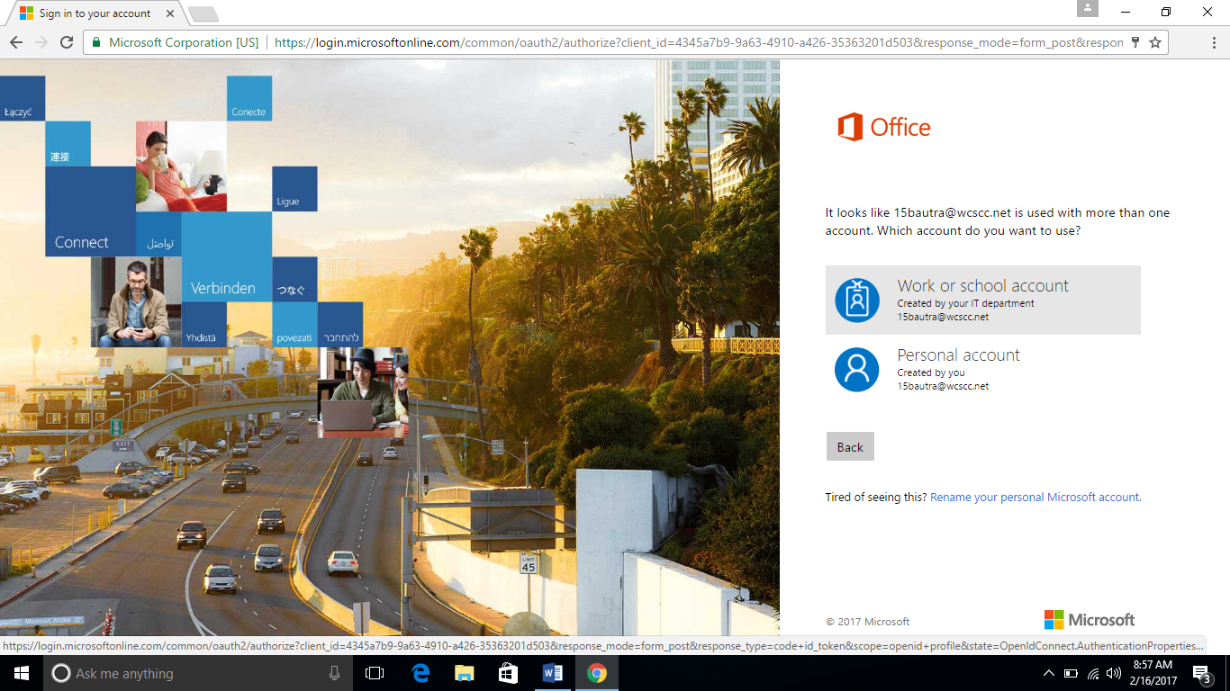

**Step 5.)** Click one the “OneDrive” icon

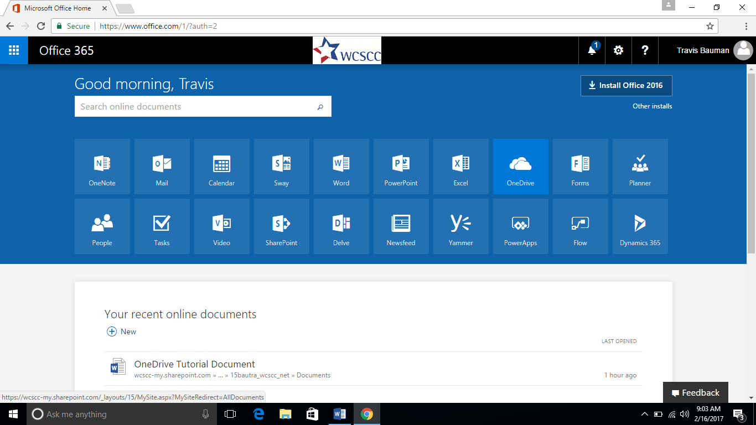

**Step 6.)** From that screen, you will see and will have access to,all off your files that are saved up on Microsoft’s Cloud “Onedrive”.